

**Ministry of Agriculture**

**Agricultural Marketing Section**

# MONTHLY MARKET BULLETIN

**July, 2024**

**Executive Summary**

Staple food prices increase and decrease in July and continue to remain at their lowest and highest levels compared to price last year and five year averages. Prices of rice, dry beans and wheat declined by 6.5%, 2.3% and 1.7% respectively, while prices of sorghum, round potatoes and maize increased by 5.0%, 3.2% and 2.1% respectively. Prices of maize is expected to ease as a result of improved supply from ongoing early-season harvesting in various production areas. Early harvesting of crops like rice, dry beans and wheat has improved supply of food crops. Food prices are expected to ease as the country is in harvesting season. Tanzania’s traditional export crops increase and decrease at different rates in July 2024. Prices of tobacco, tea, coffee robusta, coffee arabica and cotton increased by 27.2%, 5.1%, 5.1%, 3.5% and 1.7% respectively. import substitution commodities (edible oil, and wheat) and farm inputs (fertilizer) increase and decrease at different rates Price of edible oil and urea fertilizer increased by 2.5% and 1.9% respectively while price of wheat and DAP fertilizer decreased by 2.0% and 0.6% respectively.

1



## 1. Domestic Market Prices: Staple foods

### Table 1: Changes in market price of major staple foods (%)

|  |  |  |  |  |  |  |
| --- | --- | --- | --- | --- | --- | --- |
|  | **Maize** | **Rice** | **Beans** | **Potato** | **Sorghum** | **Wheat** |
| **Annual change (Jul 2023/24)** | **▼38.5%** | **▼21.1%** | **▼3.8%** | **▼0.7%** | **▲0.8%** | **▲3.3%** |
| **5 Year average** | **▼8.8%** | **▲6.3%** | **▲19.9%** | **▲21.0%** | **▲20.5%** | **▲13.3%** |
| **Monthly change (JunJul 2024)** | **▲2.1%** | **▼6.5%** | **▼2.3%** | **▲3.2%** | **▲5.0%** | **▼1.7%** |

Prices for major staple food crops increased and decreased at different rates in July, annually and five-year average (Table 1). In July, decrease in price was observed in rice 6.5, dry beans 2.3% and wheat 1.7%, while price of sorghum, round potatoes and maize increased by 5.0%, 3.2% and 2.1% respectively.

### Maize



In July, the average wholesale price increased by 2.1 percent, from TZS



61,600/100kg bag in June to TZS 62,900 in July (Table 1). Despite the July price increase, maize prices decrease by 38.5% and 8.8% lower than the previous year’s comparable month and the five-year July averages, respectively (Figure 1). Prices is expecting to ease as a result of improved supply from ongoing early-season harvesting in various production areas.

-

20,000

40,000

60,000

80,000

100,000

120,000

Jul-20

Jul-21

Jul-22

Jul-23

Jul-24

TZS/100kg bag

Figure 1: Average market price of maize during month of

July 2020

-

2024

Market price

5

year average



3

### Rice

Rice prices decreased by 6.5 percent in July, declining from TZS

214,000/100kg bag in June to TZS 200,100/100kg bag in July (Table 1). Also, prices decreased by 21.1% in July compared to the previous year's same month, and increased by 6.5% compared to the five-year July averages (Figure 2). Prices have begun to ease as a result of supply from ongoing early-season harvesting in various production areas.

-

50,000

100,000

150,000

200,000

250,000

300,000

Jul-20

Jul-21

Jul-22

Jul-23

Jul-24

TZS/100kg bag

Figure 2: Average market price of rice during month

of July 2020

-

2024

Market price

5

year average

**Dry beans**

Beans prices slightly

decreased

by

2.3

percent

in

July

, from TZS

264,100

/100

kg

bag

of

June

to

about

TZS

258,100

/100

kg

bag.

Price trend shows

a decline in prices over

the past three months. This could be due to improved supply from

various

production areas. However

, prices in

July

remained

significantly

lowe

r

by about

3.8

%

similar month

previous year and

higher than 19.9%

the five

-

year

May

average,

respectively (Figure 3).

**Sorghum**

The monthly average wholes

ale price of sorghum

increased

by

5

.0

%

in

July

TZS

from

14

1

,

9

00

/100kg

bag

in

June

to

TZS

149,000

/100kg bag in

July

. However, prices rem

ained

slightly

higher at

0.8

% in

July

compared to the same mont

h the previous year, and were

20.5

%

higher than the five

-

year

July

average.

(

Figure

4).

-

50,000

100,000

150,000

200,000

250,000

300,000

Jul-20

Jul-21

Jul-22

Jul-23

Jul-24

TZS/100kg bag

Figure 3: Average market price of dry beans during

month of July 2020

-

2024

Market price

year average

5

-

20,000

40,000

60,000

80,000

100,000

120,000

140,000

160,000

Jul-20

Jul-21

Jul-22

Jul-23

Jul-24

TZS/100kg bag

Figure 4: Average market price of sorghum during

month of July 2020

-

2024

Market price

5

year average

**Round potatoes**

In

July

, round potato wholesale prices

increased by

3.2

%

from TZS

102,200

/100kg bag in

June

to TZS

105,500

/100kg bag in

July

.

However

,

prices

decreased by 0.7

% in the reporting period compared to the same

pe

riod the previous year and 2

1

% higher than the five

-

year

July

average

5).

(

Figure

**Wheat**

Wheat grain w

holesale prices

de

creased by 1.

7

percent in

July

, from TZS

189,000

/100kg bag in

June

to TZS

185,700

/100kg bag in

July

. Pric

es on the

other hand, were

3.3

% higher in the reporting period compared to the

same period the previous year and

13.3

%

higher than the five

-

year

July

average (Figure 6).

-

20,000

40,000

60,000

80,000

100,000

120,000

Jul-20

Jul-21

Jul-22

Jul-23

Jul-24

TZS/100kg bag

Figure 5: Average market price of round potatoes

during month of July 2020

-

2024

Market price

5

year average

-

50,000

100,000

150,000

200,000

250,000

Jul-20

Jul-21

Jul-22

Jul-23

Jul-24

TZS/100kg bag

Figure 6: Average market price of wheat during month

of July 2020

-

2024

Market price

5

year average

### 2. Global Prices: Traditional Export commodities (Source: World Bank, 2024)

### Coffee

In July 2024, coffee prices have changed at different rates compared to June. Arabica prices increased by 3.5 percent but remained higher than they were a year ago. After a drop in Oct 2023 Robusta prices have been increasing, in July price of coffee has increased by 5.1 percent (Figure 7). Key risks predictions outlook, particularly for 2025 worsening weather conditions in South America could damage Brazil’s crop, and the potential emergence of La Niña, which could adversely affect production in South America and East Asia. [(World Bank, 2024)](https://openknowledge.worldbank.org/server/api/core/bitstreams/6864d537-d407-4cab-8ef1-868dbf7e07e2/content).

### Tea

Despite a slight increase in July 2024, international tea prices have been declining for the last three months. Prices at the Mombasa auction market increased by 5.1 percent in July, compared to their prices in June, from USD 2.14/kg in June 2023 to USD 2.2/kg in July 2023 (Figure 8). The moderate rise in average tea prices reflects, in part, lower production from South Asian producers, including India, Bangladesh and Sri Lanka. [(World Bank, 2024)](https://openknowledge.worldbank.org/server/api/core/bitstreams/6864d537-d407-4cab-8ef1-868dbf7e07e2/content).

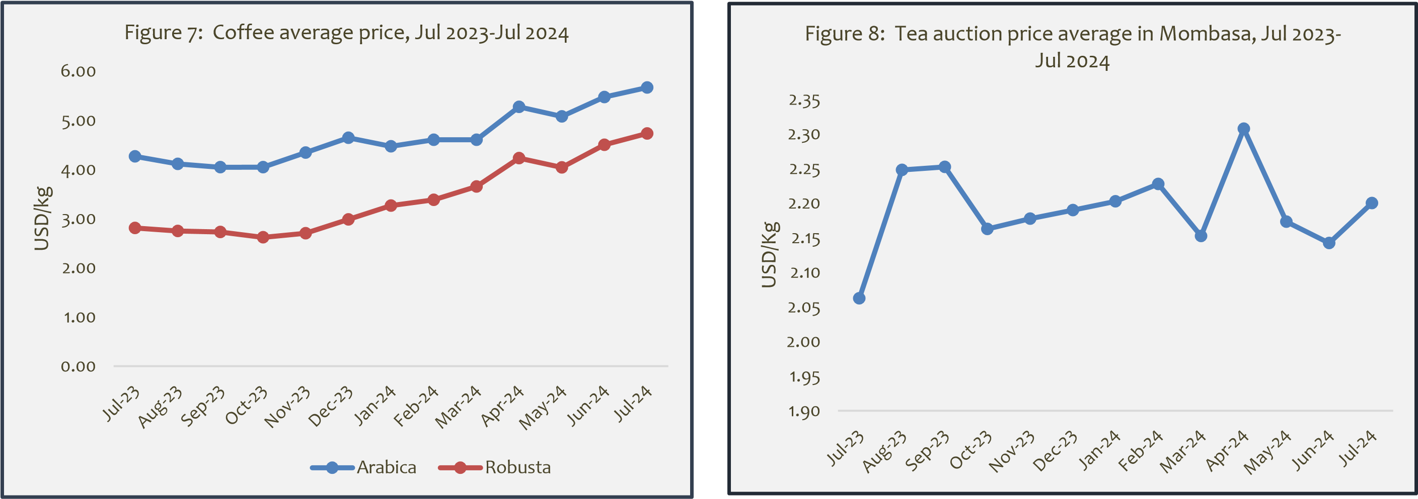

### Cotton J

|  |
| --- |
| **Tobacco**    Over the last year July 2023 global tobacco prices have been slightly increase and decrease but starting from    February to March 2024 increased from 4502.12USD/Ton to 5608.24USD/Ton respectively. However, in April  prices decreased by 16.9% but in June to July Prices    picked up to 6015.53USD/ton which is equivalent to  27.2%. (Figure 10). |

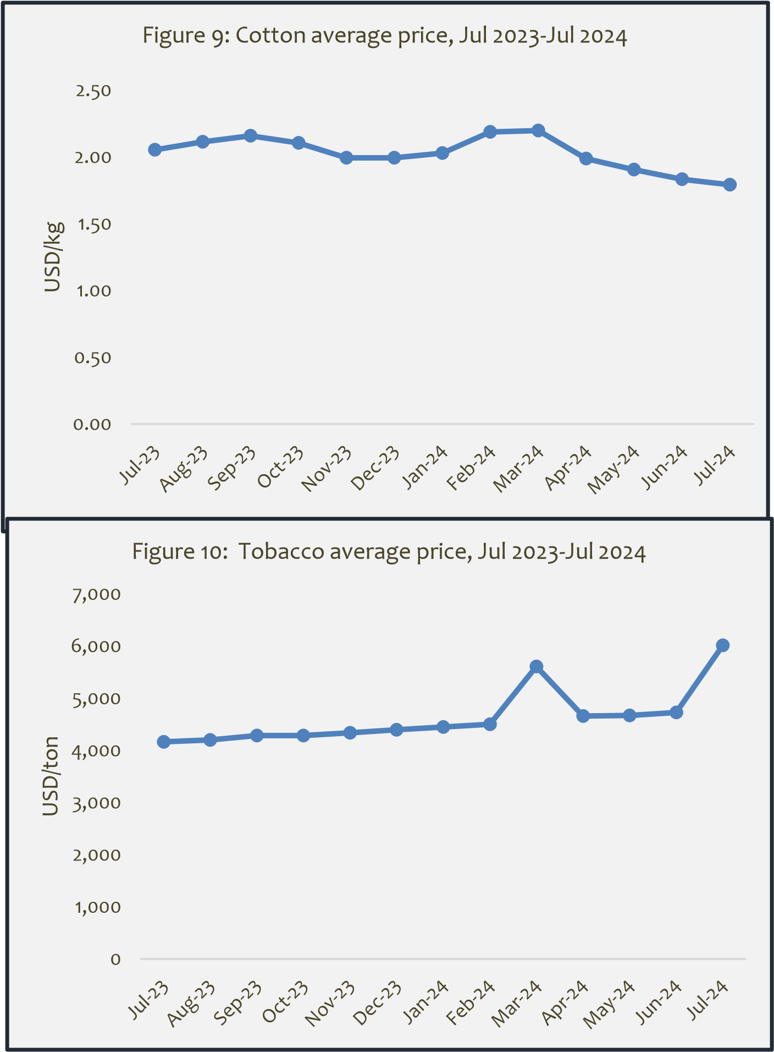Cotton prices have been increasing and decreasing over the last year but peaked at March 2024 to 2.2 USD/Kg and then slightly drop from 1.8 USD/Kg in June to 1.7USD/Kg in July. Global consumption of cotton has weakened recently causing a decline in prices, the recent decline is attributed to weakening demand and strong production prospects for the 2024-25 crop season, which has just begun.

[(World Bank, 2024)](https://openknowledge.worldbank.org/server/api/core/bitstreams/6864d537-d407-4cab-8ef1-868dbf7e07e2/content).

### 3. Import Substitution Commodities (Source: World Bank, 2024)

#### Wheat

Ukraine and Russia accounted for nearly 30% of global wheat exports. Following several months of Russia’s invasion of Ukraine, prices of wheat have soared. However, wheat observed a decline in prices from their pick in May 2024 reflecting improved supply prices (Figure 11). In July price of wheat (US HRW) decreased from 265.5 USD/ton in June to 260.26USD/ton in July which is equivalent to 2.0%.

*\*Wheat (US), Hard Red Winter (HRW) and Soft Red Winter*

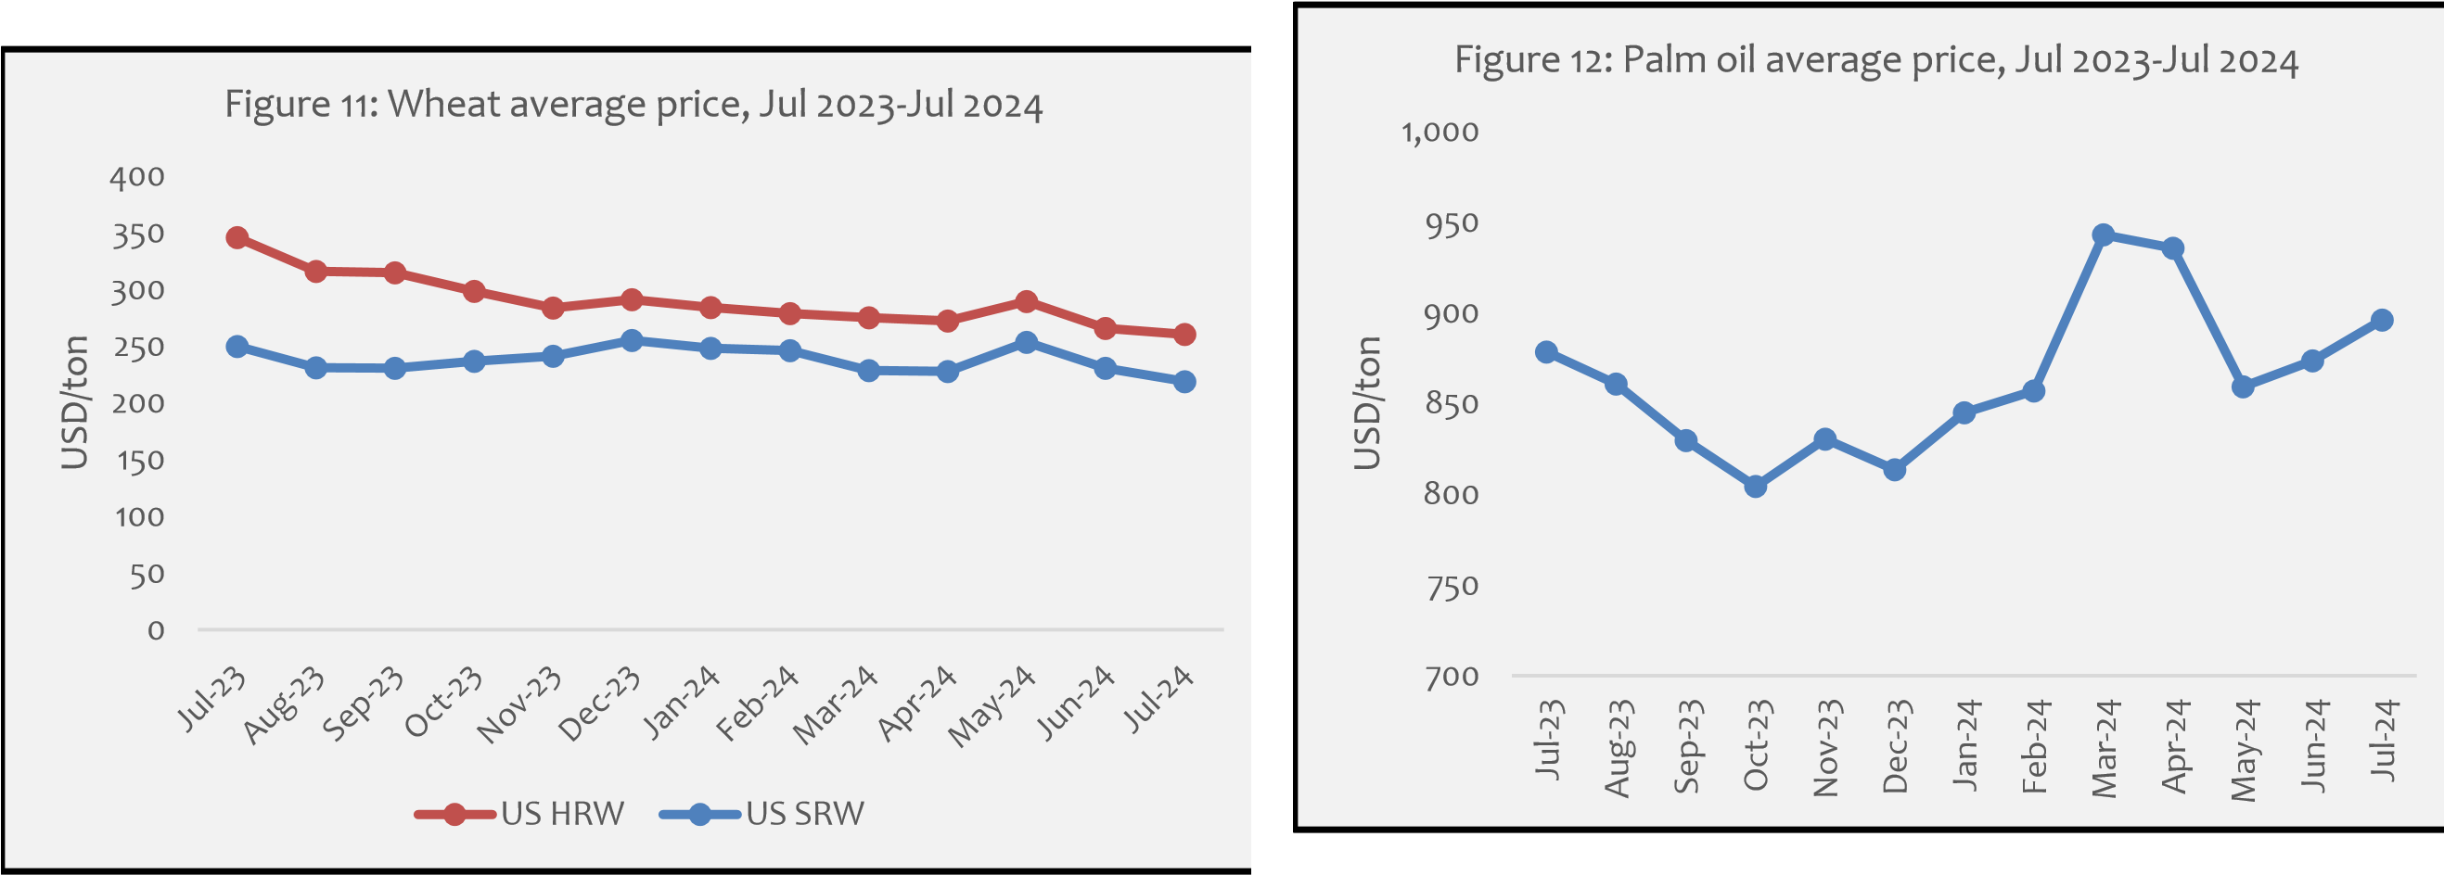

#### Edible Oil (Palm)

The price of palm oil fell sharply from its peak in March 2024 to its lowest level in May 2024, then start to increase. Palm oil prices increased marginally by 2.5% in July 2024, from USD 873.67/ton in June 2024 to USD 896.09 /ton in July 2024(Figure 12). Tanzania imports a large amount of edible oil. For the fiscal year ending June 2024, the import bill was USD mil 150.9 [(BoT,2024)](https://www.bot.go.tz/Publications/Filter/1).

**4. Farm Inputs** (Source: World Bank, 2024)

#### Fertilizer

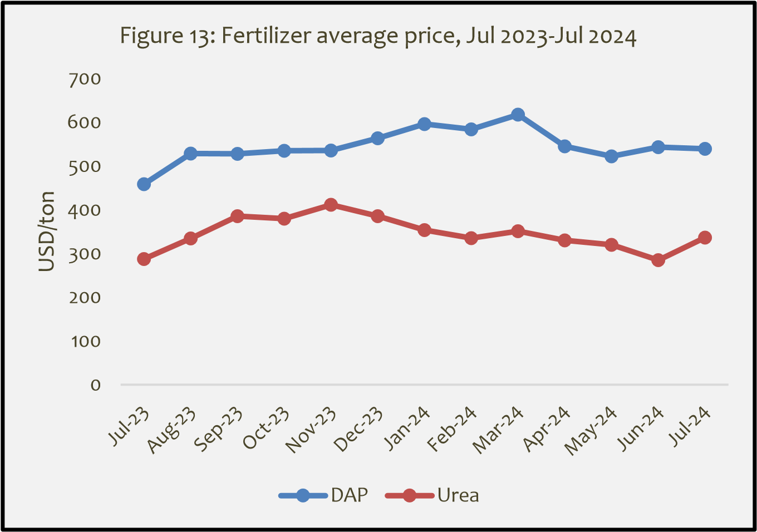Urea fertilizers recorded increase in price in July from 284.8USD/Ton in June to 336.25 USD/Ton equivalent to 1.9% while DAP fertilizers decrease from 543 USD/Ton to 539.40 USD/Ton equivalent to 0.6% (Figure 13). Tanzania imports roughly 90% of its fertilizer annual requirement. The fertilizer subsidy program, which is currently in effect, is expected to lower production costs and increase farm yield.

|  |
| --- |
| ***About the Bulletin***  This bulletin provides domestic and international markets outlook for five commodity groups including **staples** (maize, rice, beans, sorghum, and round potatoes), **traditional export crops** (coffee, cotton, tea, and tobacco), **import substitution commodities** (edible oil, and wheat) and **farm inputs** (fertilizer). This bulletin's information serves as a benchmark for key players along the respective value chains to make informed decisions.  **Disclaimer:** The views expressed in this bulletin are those of the authors and may not reflect those of the **Ministry of Agriculture (MoA)**. This bulletin is strictly for informational purposes only. The authors have made every effort to ensure accuracy of information provided; however, neither the Ministry of Agriculture nor the authors can guarantee such accuracy  **For further information, contact:**  ***Agricultural Marketing Section,*** ***P.O. Box 2182, DODOMA.***  ***Email:*** *masoko@kilimo.go.tz* |